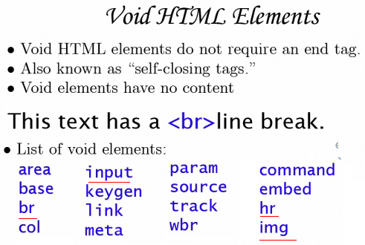



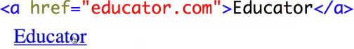

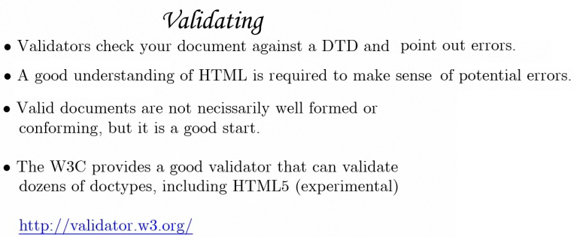

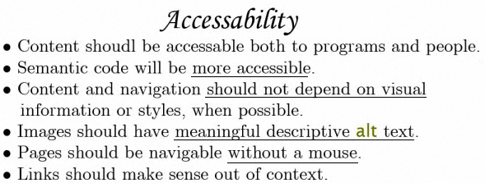

Detect if the feature is available or not with javascript

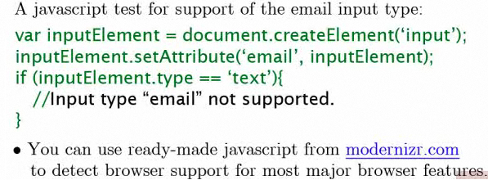

OFFLINE CACHE

- Allow web applications to function even when offline

- Not intended to improve performance

The appcache

- Browser creates an appcache when it detects a manifest file

- The appcache stores all offline data for any page that references that same manifest file

- Pages that mention that manifest file have access to the files in that appcache

Mafinest file

- cache

- fallback

- network

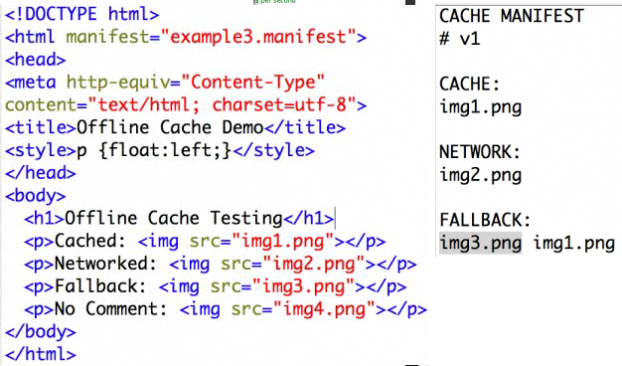

IMPORTANT TIPS



One of the key standards accelerating the adoption of SOA (service-oriented architecture) is Business Process Execution Language for web services (BPEL). BPEL was created to address the requirements of composition of web services in a service-oriented environment.

* Ability to rapidly change applications as per changing business landscape.
* Enables to automate their business processes by orchestrating services within and across the firewall.
* Communication with external vendors and partners is done through services.

